**Pemrogramman 4**

**Praktikum 8**

**Muhammad Sidratul Muntaha**

**4510210013**

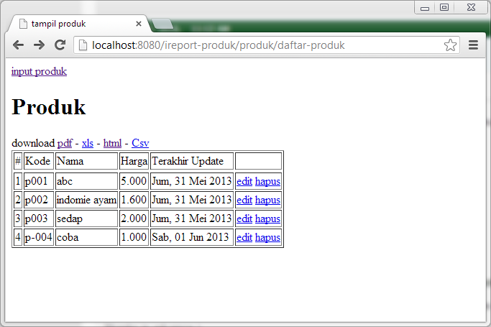

Gambar 1. Daftar Produk

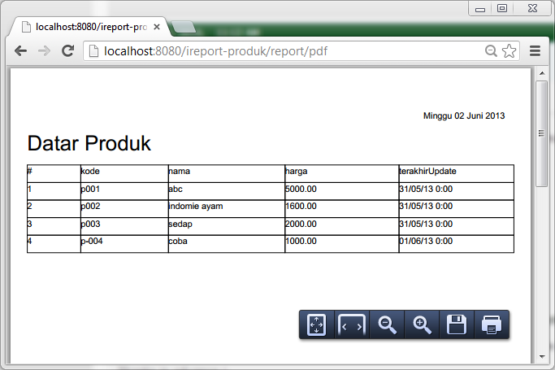

Gambar 2. PDF report

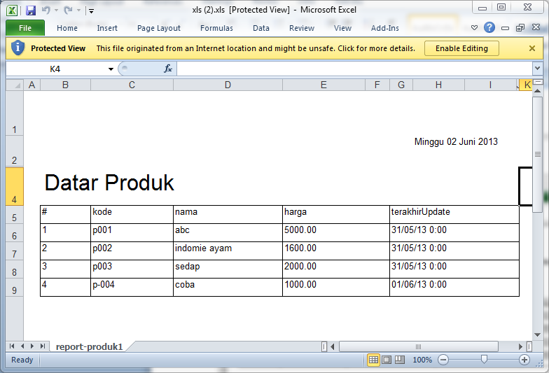

Gamabar 3. xls report

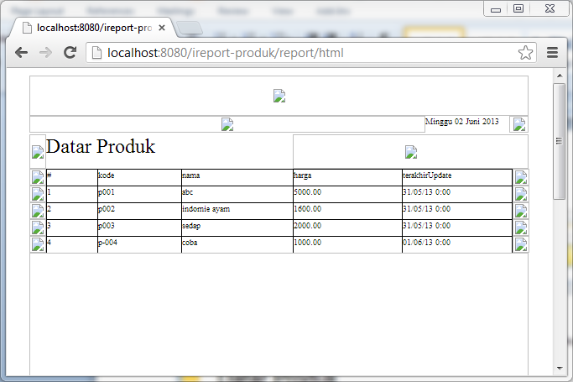

Gambar 4. html report